Module 6) JAVASCRIPT BASIC & DOM

(Basic logic Question)

**Q.1 What is JavaScript. How to use it?**

**Ans :-** JavaScript is a high-level, interpreted programming language primarily used to create interactive effects within web browsers.

* It allows developers to add dynamic functionality to websites, such as responding to user actions, manipulating HTML content, and communicating with servers asynchronously without interfering with the user's experience.
* JavaScript is an essential component of web development alongside HTML and CSS.

**How to use it :-**

(1) Embedding JavaScript:You can include JavaScript directly within an HTML document using <script> tags.

* For example:-

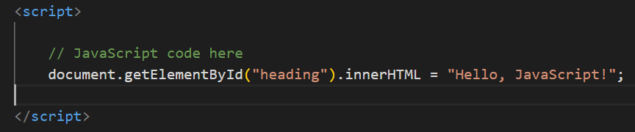

(2) External JavaScript Files:Alternatively, you can link an external JavaScript file to your HTML document using the ‘<script>’ tag's ‘src’ attribute.

* For example:-

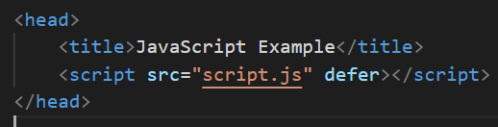

**Q.2 How many type of Variable in JavaScript?**

**Ans :-** There are three types of variables in JavaScript :-

1. **var:-** Before ES6 (ECMAScript 2015), ‘**var’** was the primary keyword used for variable declaration. Variables declared with ‘**var’** have function scope or global scope, depending on whether they are declared inside a function or not. They are also hoisted to the top of their scope during the compilation phase.
2. let:- Introduced in ES6, let allows block-scoped variables. Variables declared with ‘**let**’ are limited to the block, statement, or expression on which it is used, unlike var which is function-scoped. ‘**let’** variables are not hoisted to the top of their scope and cannot be re-declared within the same scope.
3. const :- Also introduced in ES6, ‘**const**’ is used to declare variables whose values are not intended to be re-assigned. Like ‘**let’**, ‘**const’** is also block-scoped and not hoisted. Once a value is assigned to a ‘**const’**, it cannot be changed. However, it's important to note that if the value is an object or an array, its properties or elements can still be modified.
   * + In summary:-

* var:- Function-scoped variable, hoisted.
* let:- Block-scoped variable, not hoisted, can be reassigned.
* const:- Block-scoped constant, not hoisted, cannot be reassigned (but object properties or array elements can be modified).

**Q.3 Define a Data Types in JS?**

**Ans :-** In JavaScript, data types define the type of data that can be stored and manipulated within a program. JavaScript has several built-in data types:-

1. Primitive Data Types:-
2. Number:- Represents numeric values, including integers and floating-point numbers.
3. String:- Represents sequences of characters, enclosed within single ('') or double ("") quotes.
4. Boolean:- Represents a logical value of either true or false.
5. Undefined:- Represents a variable that has been declared but not assigned a value.
6. Null:- Represents the intentional absence of any value.
7. Symbol (ES6+):- Represents unique identifiers. Symbols are often used as keys in objects to avoid naming conflicts.
8. Non-Primitive Data Types:-
9. Object: Represents a collection of properties and values, where values can be of any data type, including other objects, arrays, functions, etc.
10. Array: Represents ordered collections of values, indexed by numerical indices starting from 0.

(iii) Function: Represents reusable blocks of code that can be called and executed.

(iv) Date: Represents dates and times.

JavaScript is a dynamically typed language, meaning you don't need to specify the data type of a variable explicitly. Variables in JavaScript can hold values of any data type, and the data type is determined automatically at runtime based on the value assigned to the variable.

Here's a simple example of different data types in JavaScript:-

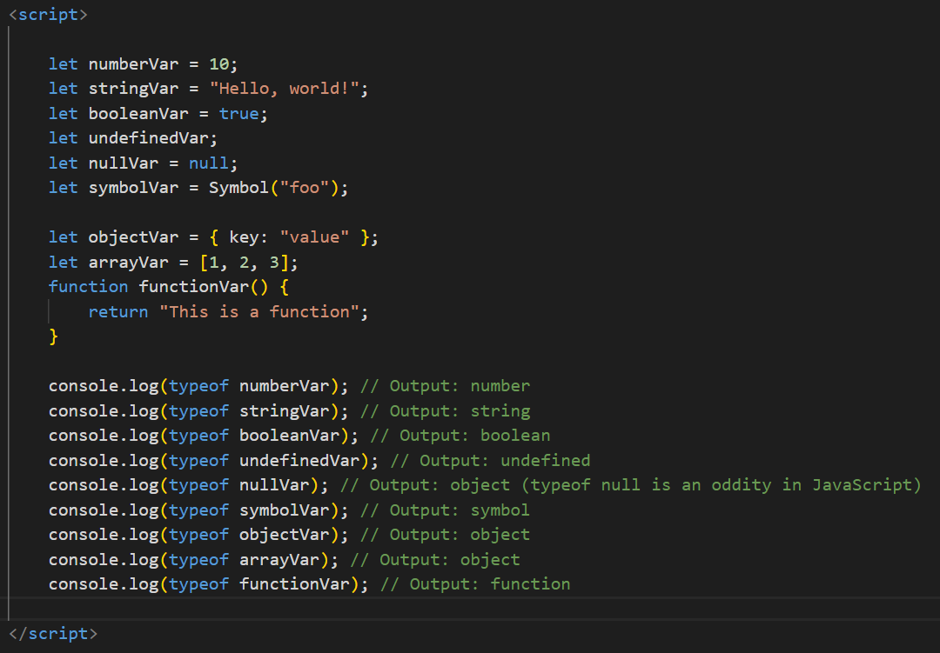

**Q.4 Write a mul Function Which will Work Properly When invoked With Following Syntax.**

**Ans :-** console.log(mul(2)(3)); // Output: 6…

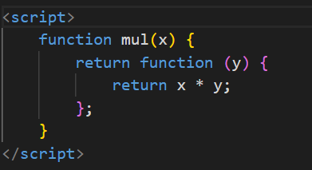

**Q.5 What the deference between undefined and undeclare in JavaScript?**

**Ans:-** In JavaScript, "undefined" and "undeclared" are two distinct concepts:-

(1) Undefined: This refers to a variable that has been declared but has not been assigned a value. It's a type in JavaScript representing the absence of a value.

* + For example:-

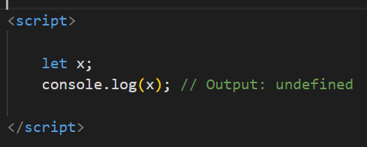

Here, ‘x’ is declared using the let keyword but hasn't been assigned a value yet. So, when you log x, you get undefined.

1. Undeclared:- This refers to a variable that has been referenced without being declared using ‘var’, ‘let’, or ‘const’. When you try to access an undeclared variable, JavaScript throws a Reference-Error.

* For example:-

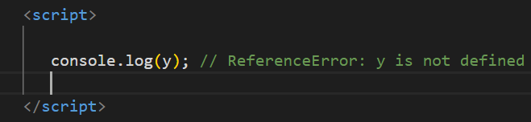

In this case, ‘y’ has not been declared anywhere in the code, so trying to access it results in a Reference-Error.

* + - In summary:-
* Undefined refers to a variable that has been declared but not assigned a value.
* Undeclared refers to a variable that has been referenced without being declared.

**Q.6 Using console.log() print out the following statement: The quote 'There is no exercise better for the heart than reaching down and lifting people up.' by John Holmes teaches us to help one another. Using console.log() print out the following quote by Mother Teresa:**

**Ans :-**

<script>

    console.log("The quote 'There is no exercise better for the heart than reaching down and lifting  people up.' by John Holmes teaches  us to help one another.");

</script>

**Q.7 Check if type of '10' is exactly equal to 10. If not make it exactly equal?**

**Ans :-**

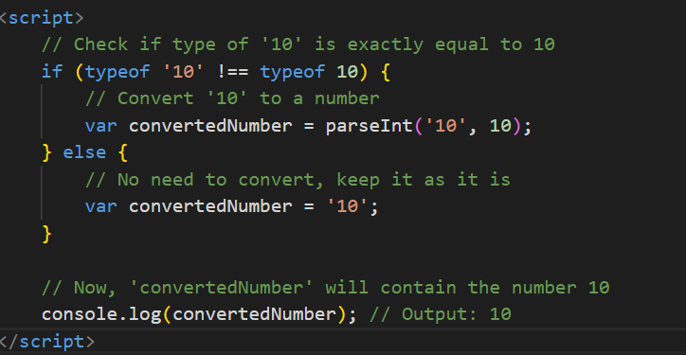

**Q.8 Write a JavaScript Program to find the area of a triangle?**

**Ans :-** You can write a JavaScript program to calculate the area of a triangle using the formula:

Area = (base * height) / 2

Here's the JavaScript code to achieve this:-

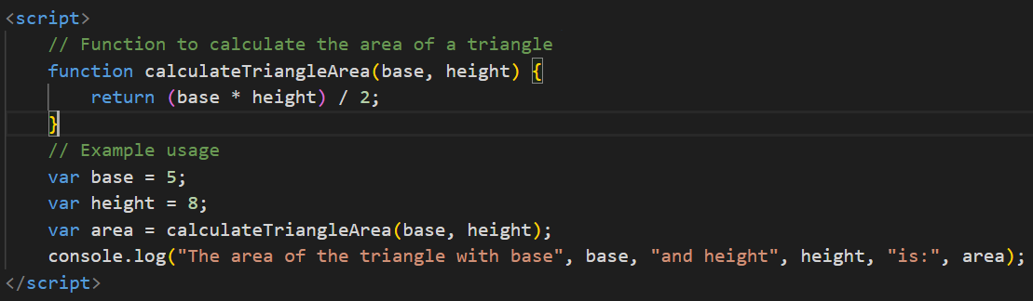

**Q.9 Write a JavaScript program to calculate days left until next Christmas?**

**Ans:-** Here's a simple JavaScript program to calculate the number of days left until the next Christmas:-

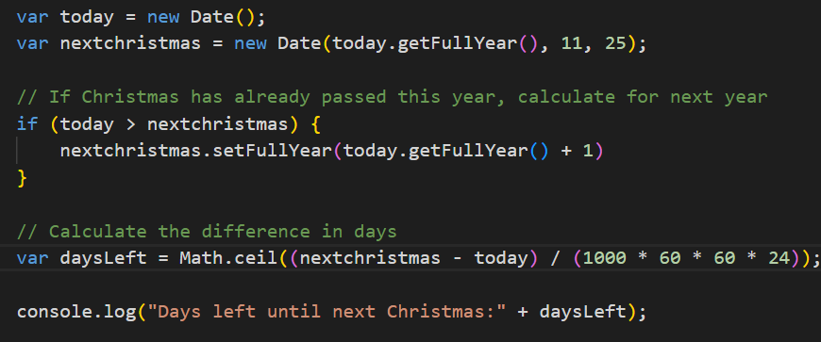

**Q.10 What is Condition Statement?**

**Ans:-** A condition statement, also known as a conditional statement or a control structure, is a programming construct that allows the execution of certain code blocks based on the evaluation of a condition or set of conditions. In essence, it enables a program to make decisions and execute different code paths depending on whether certain conditions are true or false.

* The most common types of condition statements include:-

(1) if statement: It executes a block of code if a specified condition is true. Optionally, it can include else or else if clauses to execute different blocks of code based on different conditions.

* Example:-

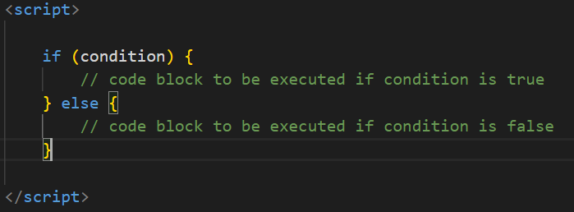

(2) switch statement: It allows a program to evaluate an expression and execute code blocks depending on matching cases.

* Example:-

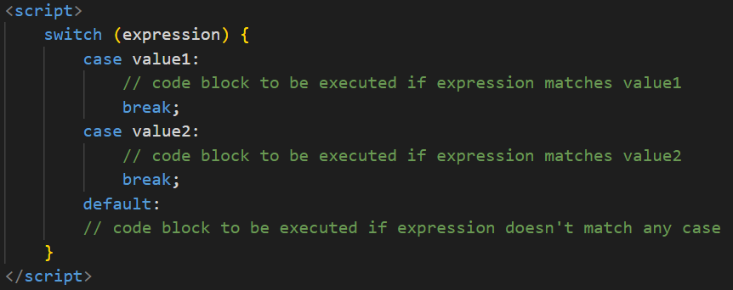

**Q.11 Find circumference of Rectangle formula : C = 4 * a ?**

**Ans:-**

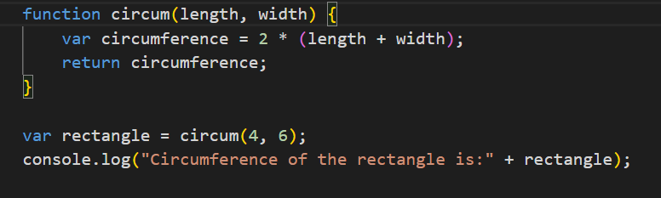

**Q.12 WAP to convert years into days and days into years?**

**Ans:-**

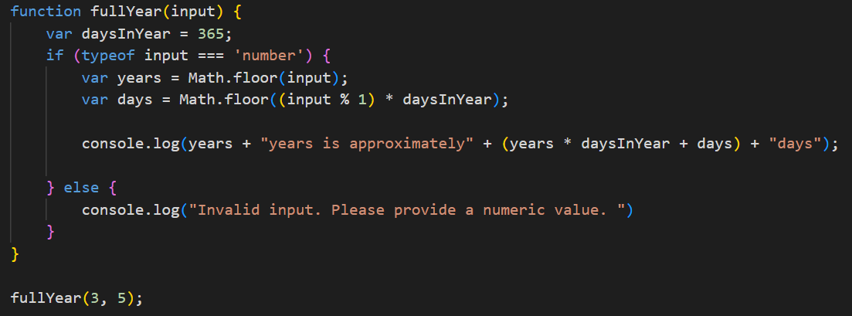

**Q.13 Convert temperature Fahrenheit to Celsius? (Conditional logic Question)**

**Ans:-** 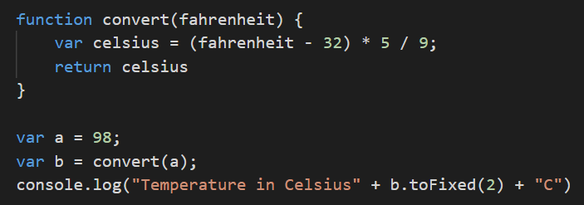

**Q.14 Write a JavaScript exercise to get the extension of a filename.?**

**Ans:-**

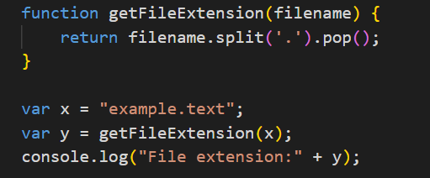

**Q.15 What is the result of the expression (5 > 3 && 2 < 4)?**

**Ans:-** The result is true because both conditions are true.

**Q.16 What is the result of the expression (true && 1 && "hello")?**

**Ans :-** The result is "hello" because all conditions are truthy, and the last truthy value is returned.

**Q.17 What is the result of the expression true && false || false && true?**

**Ans:-** The result is false because the expression is evaluated as (true && false) || (false && true).

**Q.18 What is a Loop and Switch Case in JavaScript define that ?**

**Ans:-** In JavaScript, loops and switch cases are control structures that enable you to execute code repeatedly or selectively based on certain conditions.

* Loops:-

Loops allow you to repeat a block of code multiple times. There are several types of loops in JavaScript:

1. for loop: This loop repeats a block of code a specified number of times. It consists of three optional parts: initialization, condition, and increment/decrement.

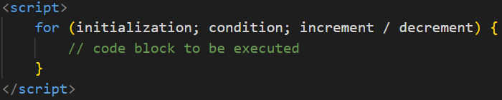

1. while loop: This loop repeats a block of code as long as a specified condition is true.

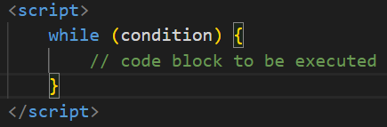

(iii) do...while loop: Similar to the while loop, but it guarantees that the code block is executed at least once before the condition is tested.

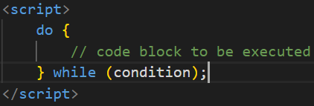

* Switch Case:-

The switch statement is used to perform different actions based on different conditions. It evaluates an expression, then executes code blocks associated with matching cases.

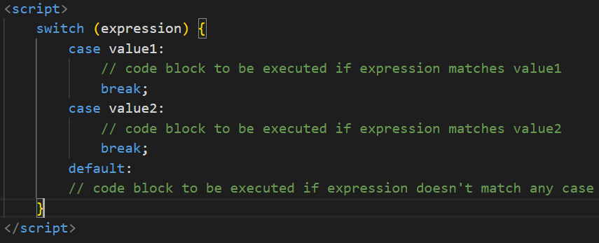

**Q.19 What is the use of is Nan function?**

**Ans:-** The ‘isNan()’ function in JavaScript is used to determine whether a value is NaN (Not-a-Number) or not. NaN is a special value representing "Not a Number", and it typically arises as a result of mathematical operations that cannot produce a meaningful result.

The ‘isNaN()’ function returns ‘true’ if the value passed to it is NaN or cannot be converted into a number; otherwise, it returns ‘false’. It is important to note that the function attempts to convert the argument to a number before checking whether it's NaN. If the argument is not of a numeric type, it will be converted to a number using the Number global object's internal conversion rules.

Here's how you can use ‘isNaN()’:-

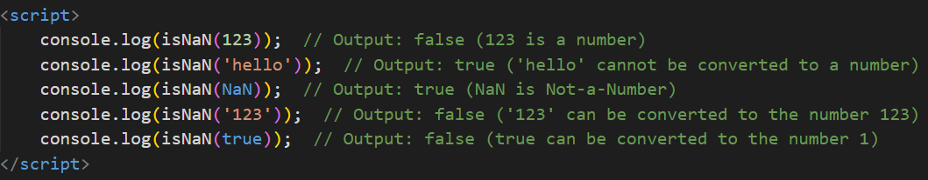

**Q.20 What is the difference between && and || in JavaScript?**

**Ans:-** In JavaScript, && (logical AND) and || (logical OR) are two different operators used for logical operations. Here's the difference between them:

* && (Logical AND):-
* The && operator returns true if both operands are true. Otherwise, it returns false.
* If the first operand evaluates to false, the second operand is not evaluated because the overall result will be false regardless of the second operand's value.
* It short-circuits: if the first operand is false, the second operand is not evaluated.
* Example:-

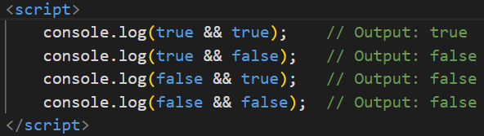

* || (Logical OR):-
* The || operator returns true if at least one of the operands is true. If both operands are false, it returns false.
* Similar to &&, if the first operand evaluates to true, the second operand is not evaluated because the overall result will be true regardless of the second operand's value.
* It also short-circuits: if the first operand is true, the second operand is not evaluated.
* Example:-

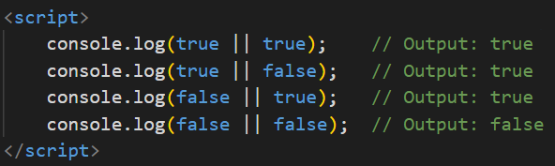

**Q.21 What is the use of Void (0)?**

**Ans:-** In JavaScript, **‘void(0)’** is a special expression that evaluates to undefined. The ‘**void**’ operator evaluates the given expression and then returns undefined, regardless of the value of the expression.

The primary use of ‘**void(0)’** is in situations where you want to ensure that a link or an action does not cause the browser to navigate away from the current page. This is often seen in HTML anchor ‘**(<a>)**’ elements where the **‘href’** attribute is set to ‘**javascript:void(0);’** or simply href="javascript:;".

Here's an example of how **‘void(0)’** is used to prevent navigation when clicking on a link:



**Q.22 Check Number Is Positive or Negative in JavaScript?**

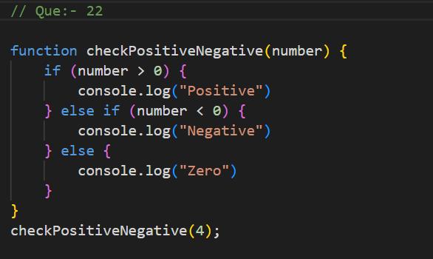

**Q.23 Find the Character Is Vowel or Not ?**

**Ans:-**

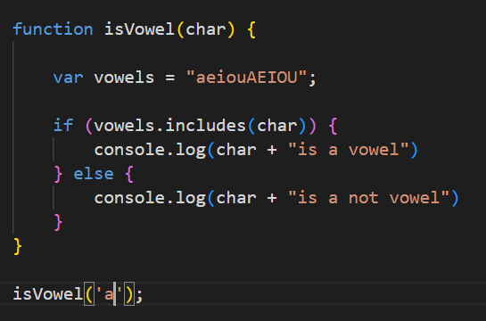

**Q.24 Write to check whether a number is negative, positive or zero?**

**Ans:-**

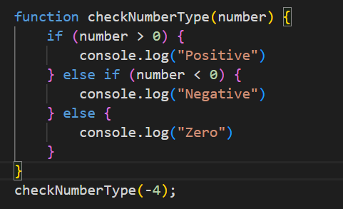

**Q.25 Write to find number is even or odd using ternary operator in JS?**

**Ans:-**

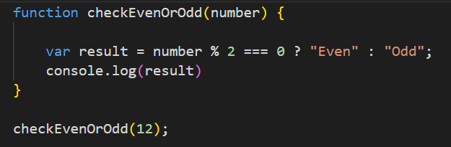

**Q.26 Write find maximum number among 3 numbers using ternary operator in JS?**

**Ans:-**

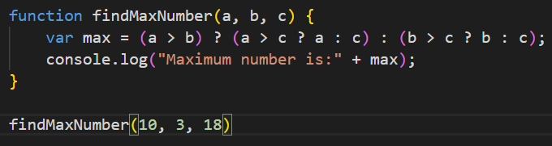

**Q.27 Write to find minimum number among 3 numbers using ternary operator in JS?**

**Ans:-**

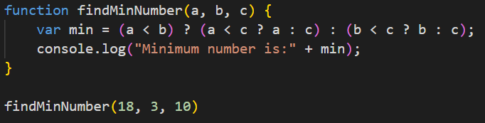

**Q.28 Write to find the largest of three numbers in JS?**

**Ans:-**

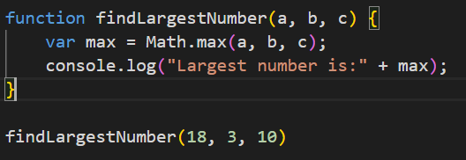

**Q.29 Write to show**

**i. Monday to Sunday using switch case in JS?**

**Ans:-**

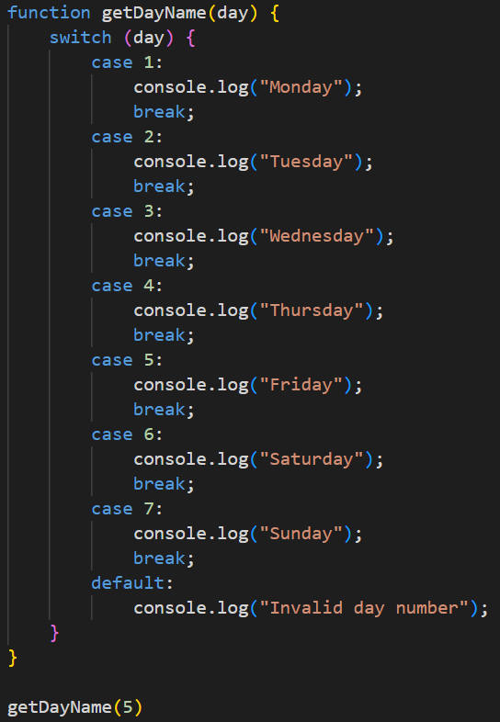

**ii. Vowel or Consonant using switch case in JS?**

**Ans:-**

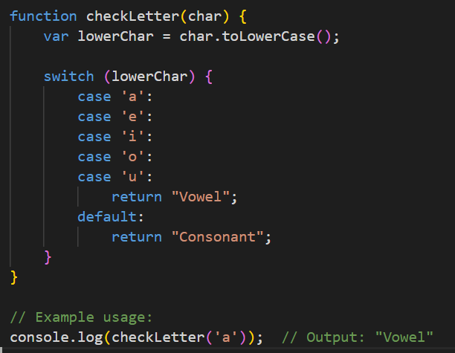

(Conditional looping logic Question)

**Q.30 What are the looping structures in JavaScript? Any one Example?**

**Ans:-** In JavaScript, there are several looping structures that allow you to execute a block of code repeatedly.

Here are the main looping structures:-

(1) for loop:- It repeats a block of code a specified number of times. It's often used when the number of iterations is known beforehand.

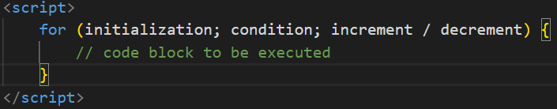

(2) while loop:- It repeats a block of code as long as a specified condition is true. It's suitable when you don't know the number of iterations beforehand.

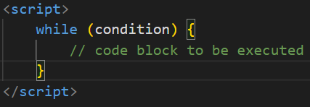

(3) do...while loop: Similar to the while loop, but it guarantees that the code block is executed at least once before the condition is tested.

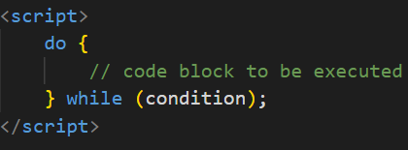

(4) for...in loop: It iterates over the enumerable properties of an object. It's often used for iterating over the keys of an object.

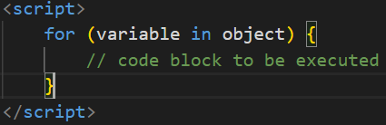

(5) for...of loop (introduced in ECMAScript 6): It iterates over iterable objects, such as arrays, strings, maps, sets, etc.

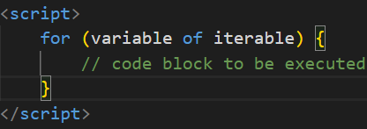

**Q.31 Write a print 972 to 897 using for loop in JS?**

**Ans:-**

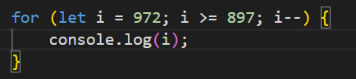

**Q.32 Write to print factorial of given number?**

**Ans:-**

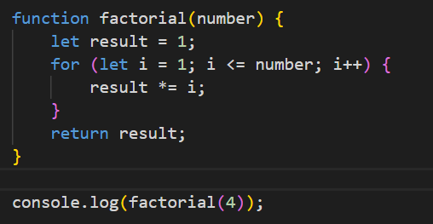

**Q.33 Write to print Fibonacci series up to given numbers?**

**Ans:-**

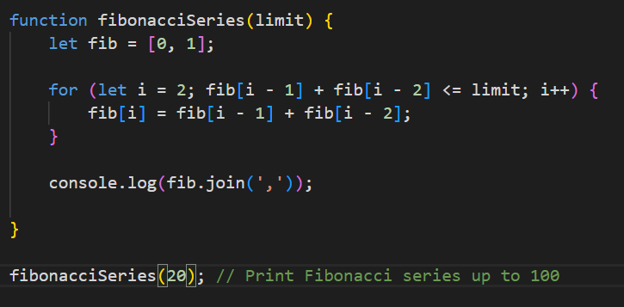

**Q.34 Write to print number in reverse order e.g.: number = 64728**

**---> reverse =82746 in JS?**

**Ans:-**

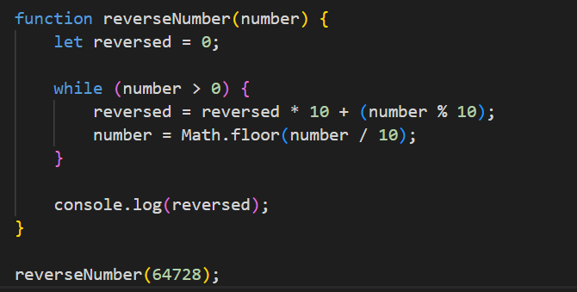

**Q.35 Write a program make a summation of given number (E.g., 1523 Ans: - 11) in JS?**

**Ans:-**

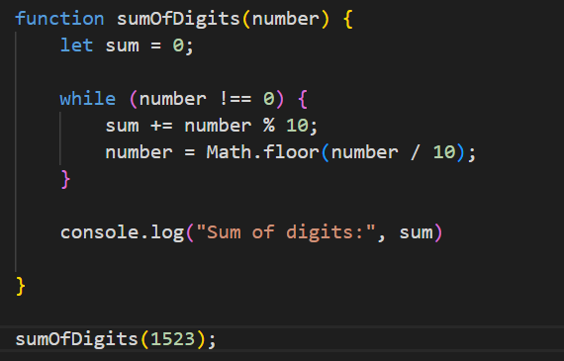

**Q.36 Write a program you have to make a summation of first and last Digit. (E.g., 1234 Ans: - 5) in JS?**

**Ans:-**

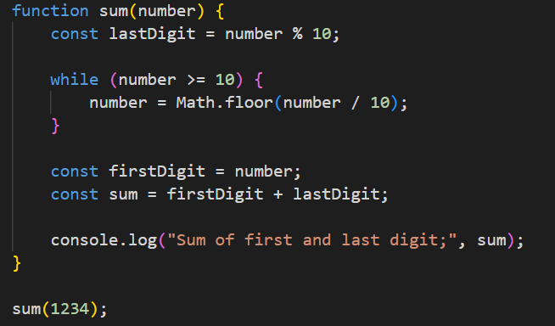

**Q.37 Use console.log() and escape characters to print the following pattern in JS?**

**Ans:-**

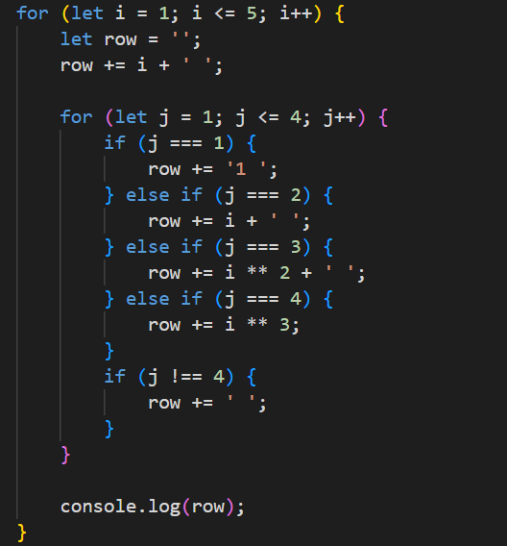

**Q.38 Use pattern in console.log in JS?**

**Ans:-**

**1)**

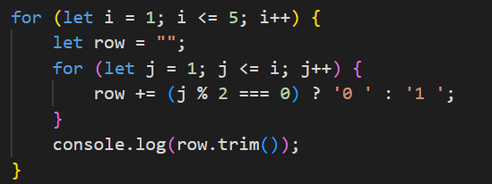

**2)**

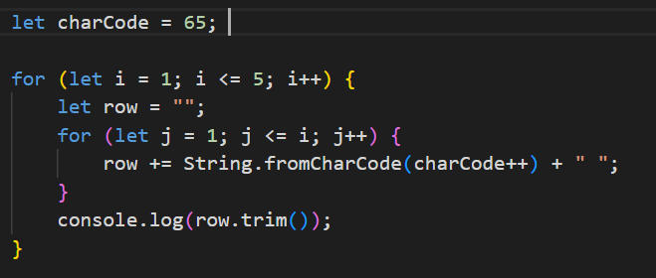

**3)**

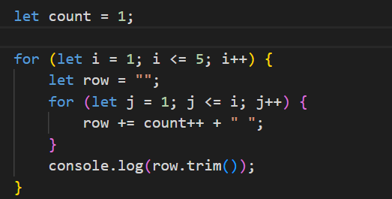

**4)**

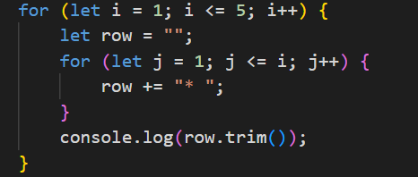

**Q.39 Accept 3 numbers from user using while loop and check each numbers palindrome?**

**Ans:-**

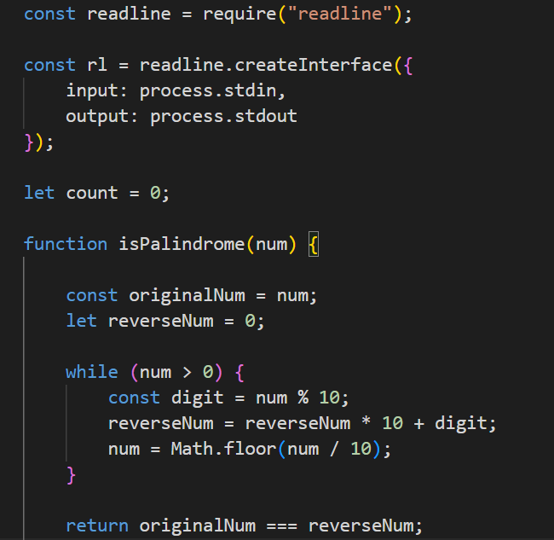

(Array and object Question)

**Q.40 Write a JavaScript Program to display the current day and time in the following format. Sample Output: Today is Friday. Current Time is 12 PM: 12 : 22 2 ?**

**Ans:-**

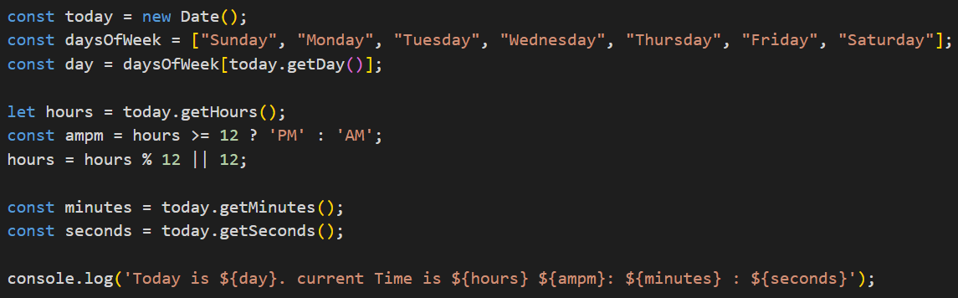

**Q.41 Write a JavaScript program to get the current date?**

**Ans:-**

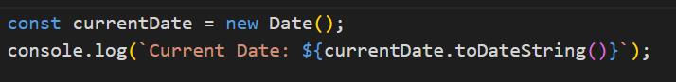

**Q.42 Write a JavaScript program to compare two objects?**

**Ans:-**

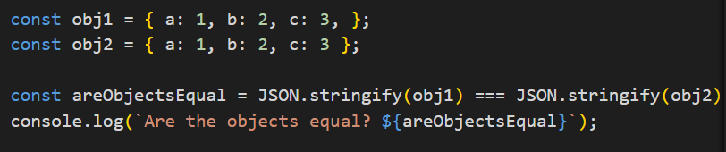

**Q.43 Write a JavaScript program to convert an array of objects into CSV string?**

**Ans:-**

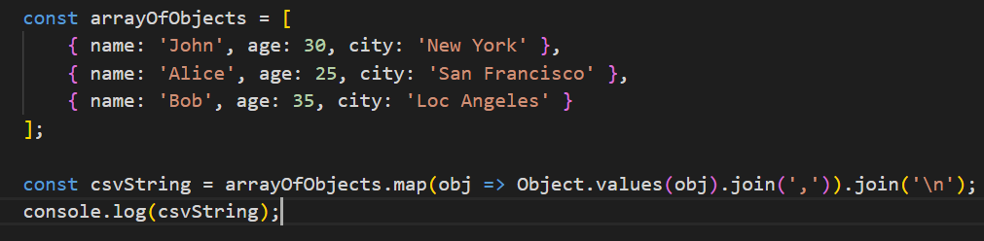

**Q.44 Write a JavaScript program to capitalize first letter of a string?**

**Ans:-**

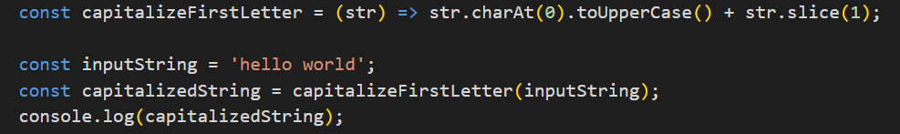

**Q. 45 Write a JavaScript program to determine if a variable is array?**

**Ans:-**

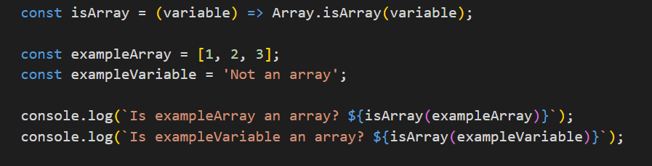

**Q.46 Write a JavaScript program to clone an array?**

**Ans:-**

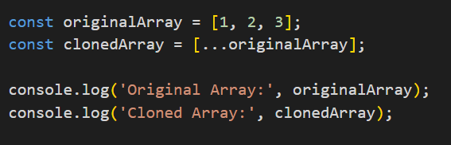

**Q.47 What is the drawback of declaring methods directly in JavaScript objects?**

**Ans:-** The main drawback is that methods declared directly in JavaScript objects are duplicated for each instance of the object, which consumes more memory. If the method is the same for all instances, it's more memory-efficient to declare it in the object's prototype.

**Q.48 Print the length of the string on the browser console using console.log()?**

**Ans:-**

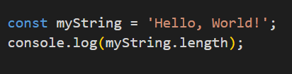

**Q.49 Change all the string characters to capital letters using to Upper-Case() method?**

**Ans:-**

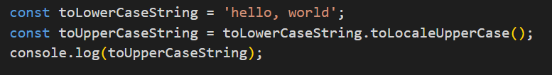

**Q.50 What is the drawback of declaring methods directly in JavaScript objects?**

**Ans:-** As mentioned earlier, the main drawback is that methods declared directly in JavaScript objects are duplicated for each instance of the object, which can lead to increased memory consumption. This is not memory-efficient, especially if the methods are the same for all instances. Declaring methods in the prototype allows them to be shared among all instances of the object, reducing memory usage.

**Q.51 Write a JavaScript program to get the current date. Expected Output : mm-dd-yyyy, mm/dd/yyyy or dd-mm-yyyy, dd/mm/yyyy?**

**Ans:-**

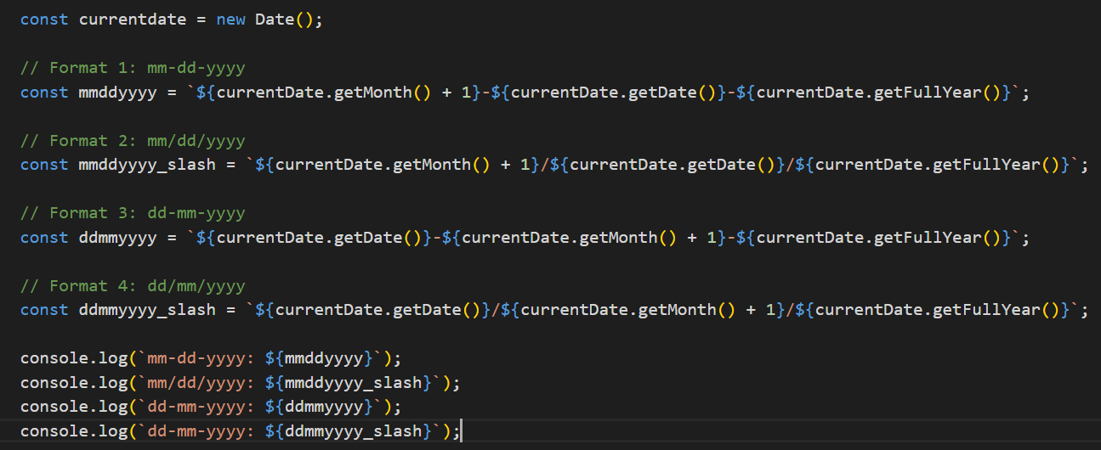

**Q.52 Use index-of to determine the position of the first occurrence of a in 30 Days Of JavaScript?**

**Ans:-**

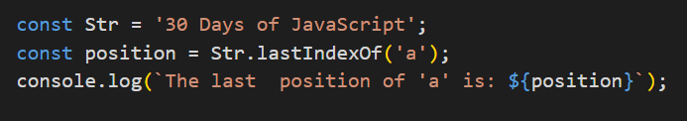

**Q,53 Use last-Index-Of to determine the position of the last occurrence of a in 30 Days Of JavaScript?**

**Ans:-**

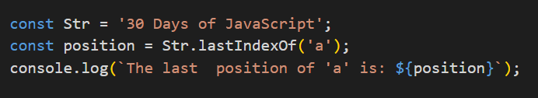

**Q.54 Form Validation in JS?**

**Ans:-**

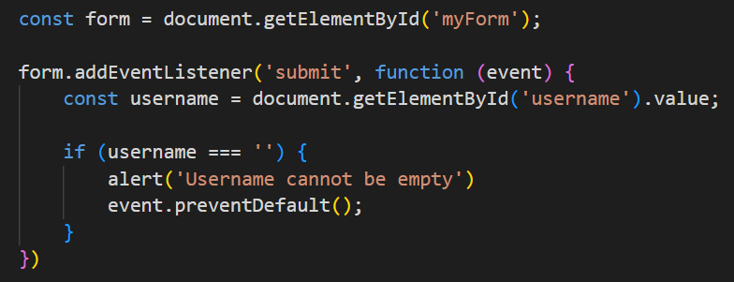

**Q.55 Form in Email, number, Password, Validation?**

**Ans:-**

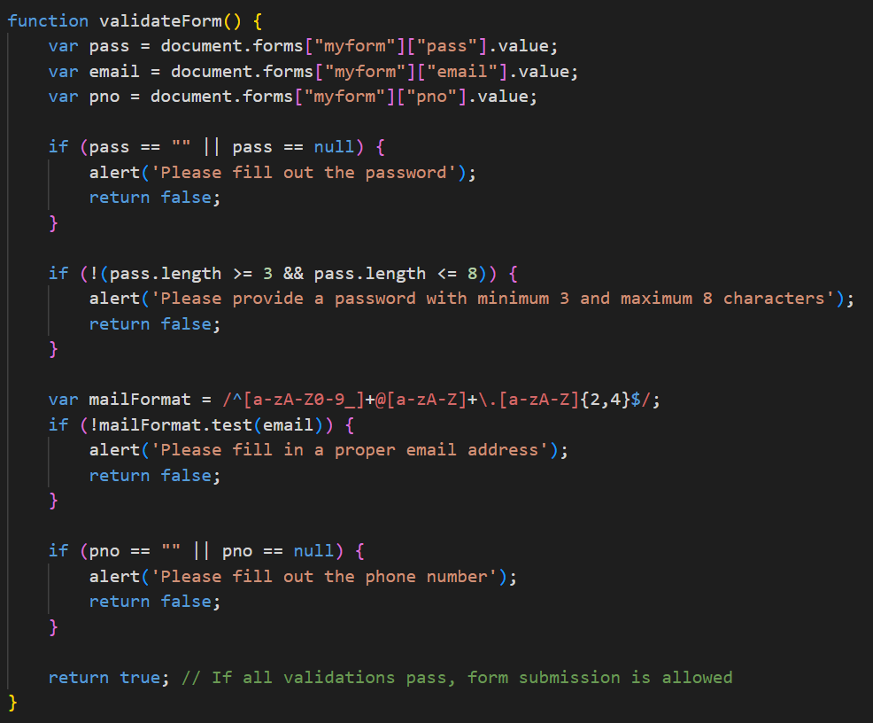

**Q.56 Dynamic Form Validation in JS?**

**Ans:-**

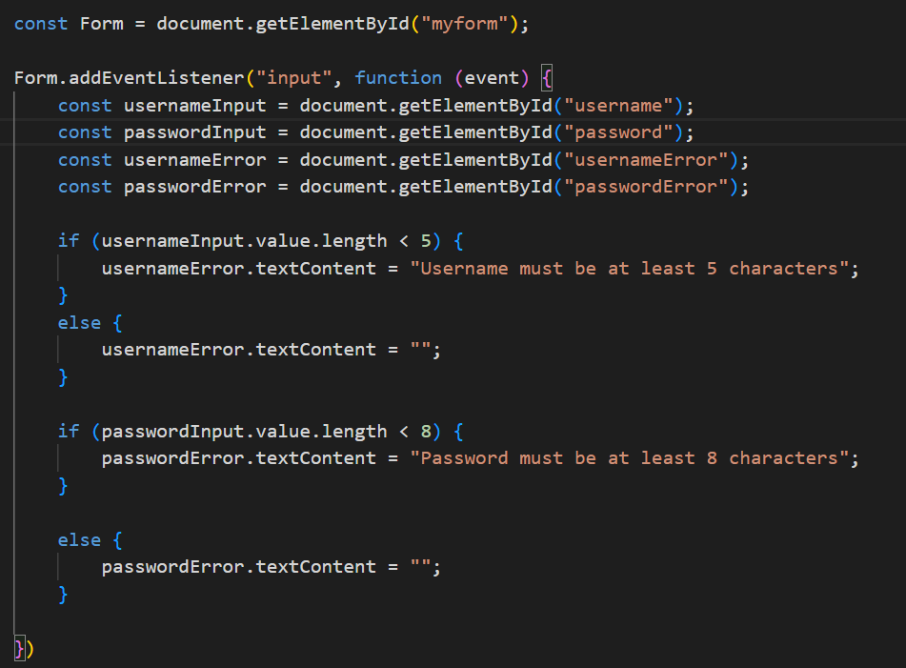

**Q.57 How many types of JS events? How to use them?**

**Ans:-**

|  |
| --- |
| **Event Description**  **onchange An HTML element has been changed**  **onclick The user clicks an HTML element**  **onmouseover The user moves the mouse over an HTML**  **element**  **onmouseout The user moves the mouse away from an**  **HTML element**  **onkeydown The user pushes a keyboard key onload**  **The browser has finished loading the page** |

**Q.59 What is Bom vs Dom in JS?**

**Ans:- *DOM*:** It represents the structure of a document as a tree of objects. The DOM is used to interact with HTML or XML documents.

***BOM*:** It represents the browser as an object. It includes objects like window, navigator, location, screen, and document (which is part of the DOM).

**Q.60 Array vs object defences in JS?**

**Ans:-** Arrays are ordered collections of values, accessed by numerical indices

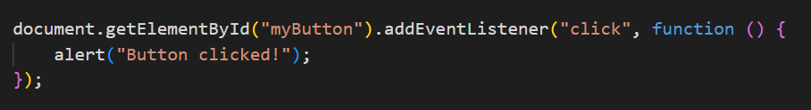

**Q.61 Split the string into an array using split() Method?**

**Ans:-** The split() method in JavaScript is used to split a string into an array of substrings based on a specified delimiter.

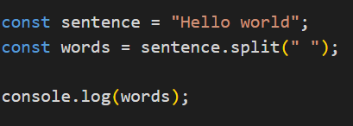

**Q.62 Check if the string contains a word Script using includes() method?**

**Ans:-** The includes() method checks if a string contains a specific substring and returns a boolean value.

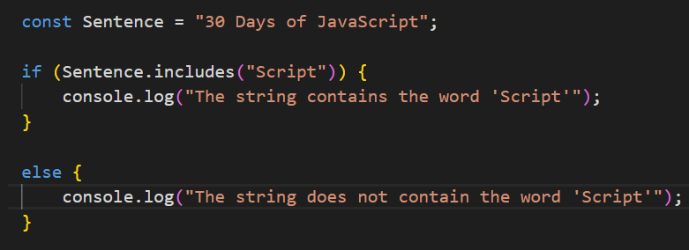

**Q.63 Change all the string characters to lowercase letters using toLowerCase() Method.**

**Ans:-** The toLowerCase() method in JavaScript is used to convert all characters in a string to lowercase

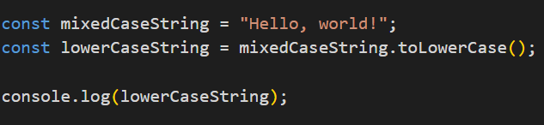

**Q.64 What is Character at index 15 in ’30 Days of JavaScript’ string? Use charAt() method.**

**Ans:-** The charAt() method in JavaScript is used to get the character at a specified index in a string

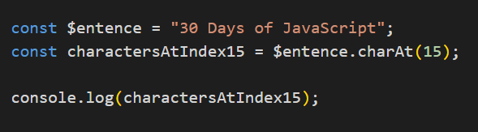

**Q.65 copy to one string to another string in JS? Q.66 Find the length of a string without using libraryFunction?**

**Ans:-**

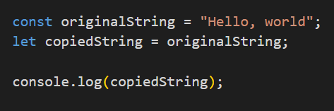

**Q.66 Find the length of a string without using libraryFunction?**

**Ans:-** 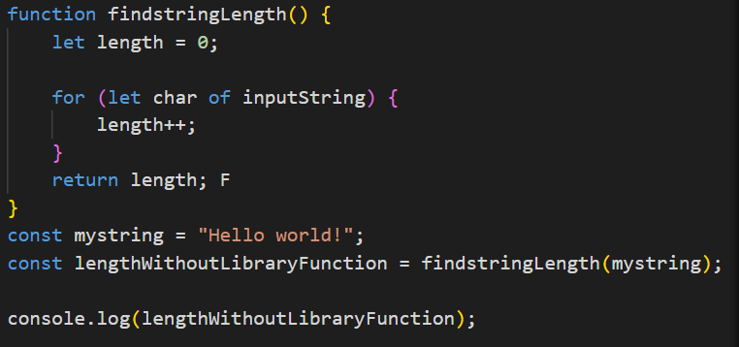

**• What is JavaScript?**

**Ans:- JavaScript is a high-level programming language primarily used for creating interactive and dynamic content on websites. It was initially developed by Brendan Eich at Netscape Communications Corporation in 1995 and has since become one of the most widely used programming languages, not only for web development but also for server-side development, mobile app development, game development, and more.**

**• What is the use of isNaN function?**

**Ans:-** The isNaN() function in JavaScript is used to determine whether a value is "Not-a-Number" (NaN). NaN is a special value in JavaScript that represents the result of an operation that cannot be expressed as a valid number.

**• What is negative Infinity?**

**Ans:- In JavaScript, Negative Infinity is a special value representing the mathematical concept of negative infinity. It is the opposite of positive infinity (Infinity).**

**Negative Infinity represents the smallest possible negative number, beyond any finite negative number. It is often used to indicate a value that is smaller than any other value, including negative numbers, positive numbers, and even positive infinity.**

**• Which company developed JavaScript?**

**Ans:- JavaScript was developed by Netscape Communications Corporation, a company founded in 1994 that played a significant role in the early days of the World Wide Web. JavaScript was created by Brendan Eich in 1995 while he was working at Netscape. Initially named "Mocha," it was later renamed "LiveScript" before finally being renamed "JavaScript" to capitalize on the popularity of Java at the time. JavaScript was introduced in Netscape Navigator 2.0 in 1995, marking the beginning of its widespread adoption and use in web development.**

**• What are undeclared and undefined variables?**

**Ans:- Undeclared variables are those that have not been declared in any scope.**

**Undefined variables are those that have been declared but not assigned a value, or when accessing properties that don't exist on an object.**

**It's important to differentiate between these two concepts because they can lead to different types of errors and debugging challenges in JavaScript code.**

**• Write the code for adding new elements dynamically?**

**Ans:-**

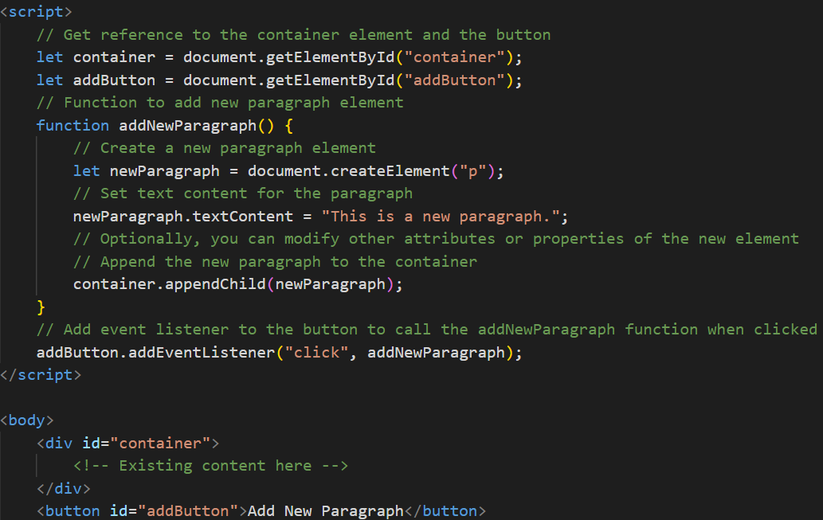

**• What is the difference between ViewState and SessionState?**

**Ans:- ViewState is used to maintain the state of a single web page across postbacks, while SessionState is used to store user-specific data across multiple pages within the same session. ViewState is client-side and specific to a page, while SessionState is server-side and spans multiple pages within a session.**

**• What is === operator?**

**Ans:- The === operator, also known as the "strict equality operator," is a comparison operator in JavaScript. It compares two values for equality without performing type conversion. In other words, it checks if the values are not only equal in value but also of the same data type.**

**• How can the style/class of an element be changed?**

**Ans:-**

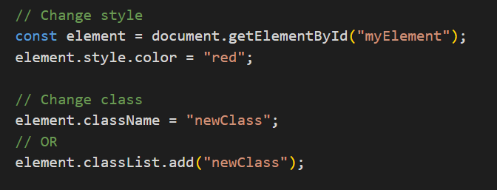

**• How to read and write a file using JavaScript?**

**Ans:-** To read and write files using JavaScript, you can use different methods depending on the environment you are working in: browser-based JavaScript or server-side JavaScript (Node.js).

Reading a File:

Browser-based JavaScript:

In a web browser environment, you can't directly read files from the user's filesystem for security reasons. However, you can allow users to select files using an HTML input element and then read the contents of the selected file using the FileReader API.

**• What are all the looping structures in JavaScript?**

**Ans:-** JavaScript supports several looping structures:

for loop

while loop

do-while loop

for...in loop (used for iterating over object properties)

for...of loop (used for iterating over iterable objects like arrays)

**• How can you convert the string of any base to an integer in JavaScript?**

**Ans :-**

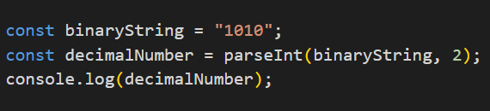

**• What is the function of the delete operator?**

**Ans:-** In JavaScript, the delete operator is used to remove a property from an object. It can also be used to remove an element from an array, but it leaves a hole in the array (i.e., the length of the array doesn't change).

**• What are all the types of Pop up boxes available in JavaScript?**

**Ans:-** JavaScript provides several types of popup boxes for displaying messages or prompting user input. These popup boxes are commonly used to interact with users and gather information. Here are the main types:

(1).Alert Box.

(2).Confirm Box.

(3). Prompt Box.

(4). Custom Popup:

**• What is the use of Void (0)?**

**Ans**:- In JavaScript, void(0) is often used to evaluate an expression and return undefined. It's typically used in the context of anchor (<a>) elements in HTML to create "empty" links, where clicking the link doesn't cause the browser to navigate to a new page.

**• How can a page be forced to load another page in JavaScript?**

**Ans:-** You can use the window.location object to navigate to another page.

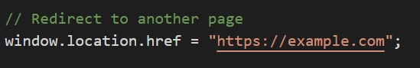

**• What are the disadvantages of using innerHTML in JavaScript?**

**Ans:-** Using innerHTML to manipulate or append content can have security implications, as it may execute scripts included in the HTML string. It's also less efficient than alternative methods like createElement and appendChild because it requires the browser to parse and re-render the entire HTML content of an element.